***Version of Windows***

1. Windows 1.X
2. Windows 2.X
3. Windows 3.0
4. Windows 3.1 and NT 3.X
5. Windows 95
6. Windows NT 4.0
7. Windows 98
8. Windows 2000
9. Windows Millennium Edition(ME)
10. Windows XP
11. Windows server 2003
12. Windows XP x64 and Server 2003 x64
13. Windows Vista
14. Windows server 2008
15. Windows 7
16. Windows 8
17. **Windows 10**

We will study windows 10 in this course.

***General Introduction for windows 10***

Windows 10 was released to consumers on the 29th of July 2015 as the successor to Windows 9. This latest version of the Windows operating system introduced what the company called “universal apps”, apps that are developed to work on smartphones, personal computers, video game consoles.

**Starting Windows :** Switch on your computer. Various items appear briefly on the screen while the computer is starting up. The first thing you see when the computer has finished its starting up is the desktop screen as shown in **Figure (1)**.

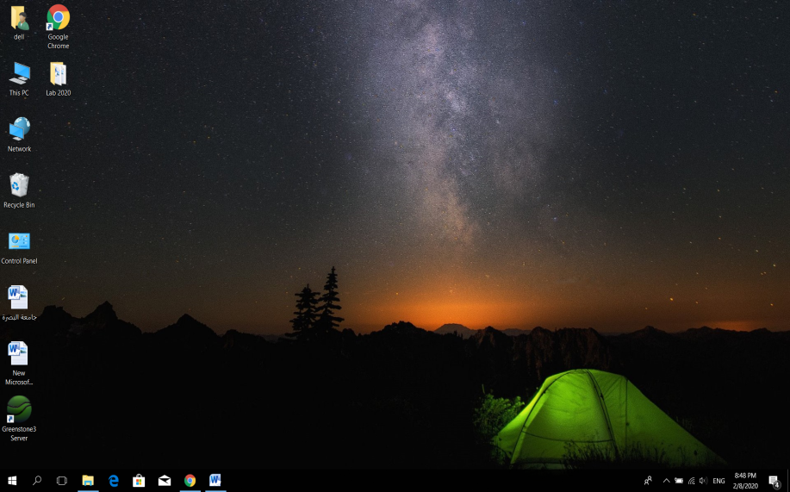

**Figure (1)**

**1-Icons**: small pictures representing applications, files and folders are also called Icons.

2-**The start menu button**start menu is a table of contents to all the apps (programs), folders and contacts you use often. In Desktop mode, all the app icons appear in an alphabetical list on the left side of the screen, and they can be made to appear on the right side as tiles. If the tiles are "live," they can display changing information from the application in real time such as stock quotes or the weather. Sometimes they just cycle through images for entertainment.

3-**The taskbar** is located at the bottom of your screen. The taskbar use for more than seeing your apps and checking the time. You can personalize it in many ways—change the color and size, pin your favorite apps to it, move it around on your screen, and rearrange or resize taskbar buttons. You can also lock the taskbar to keep your options, check your battery status, and minimize all open programs momentarily so that you can take a look at your desktop.

***Display the major system information***

Right click on computer →properties , as shown in **Figure (2)**

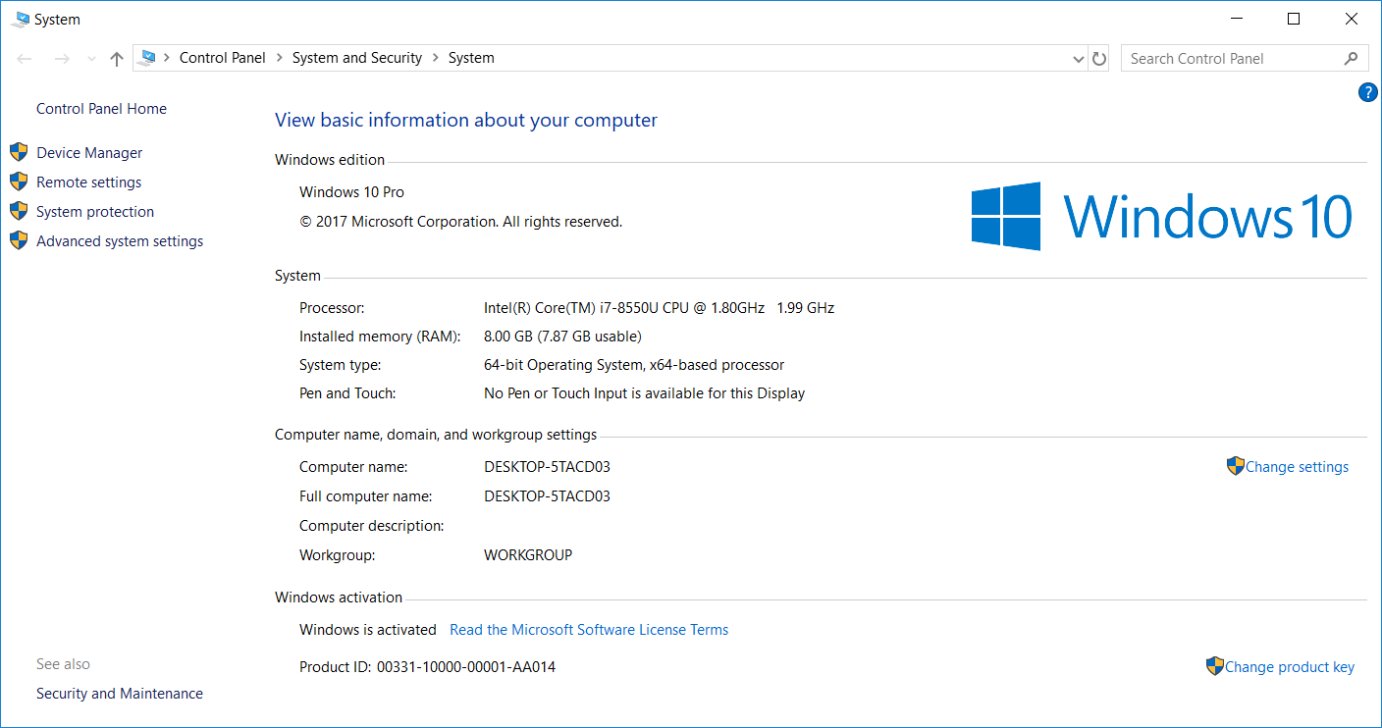

**Figure (2)**

**-How to know the storage of the HardDisk in the computer:**

Right click on computer mange storage Disk Management HardDisk storage

**-How to know the type of Hard Disk (SSD or HDD):**

**Start windows administrative tools Defragment and optimize Drives**

**-How many cells in the CPU of computer:**

Search box msinfo32

***Windows 10 System requirements***

If you want to run windows 10 on your computer, here's what it takes :

* **Processor:** 1 gigahertz (GHz) or faster processor .
* **RAM:** 1 gigabyte (GB) for 32-bit or 2 GB for 64-bit.
* **Hard disk space:** 16 GB for 32-bit OS or 20 GB for 64-bit OS.

***Working in a windows environment***

General terms that are using in the windows system environment such as : desktop, GUI, icons, folder, file, start, task bar, click.

***Use a Mouse***

**A mouse** is a small handheld input device that controls a computer screen's cursor or pointer in conjunction with the way it is moved on a flat surface.pointer usually appears in the shape of an arrow. The mouse term name originates from its likeness to a small, corded and elliptical shaped device that looks like a mouse tail. Some mouse devices have integrated features, such as extra buttons that may be programmed and assigned with different commands.

1. **Clicking** : move the mouse , to position the pointer on an object and then click the left button. Commonly used to select an object .
2. **A double click** : involves the same motion as a click ,except you click twice in rapid succession.
3. **Right click** :position the pointer on the object and then click the right side of the mouse .
4. **Dragging &Releasing** : move the pointer to the desired location. Hold down the left mouse button and then move to the new location. Release the mouse button. Commonly used to move objects.

***Task Bar***

The taskbar is a bar , usually located at the bottom of the screen . It contains the Start button ,programs and files that are currently in use and the notification area. as shown in **Figure (3)**the taskbar consists of the following

4

5

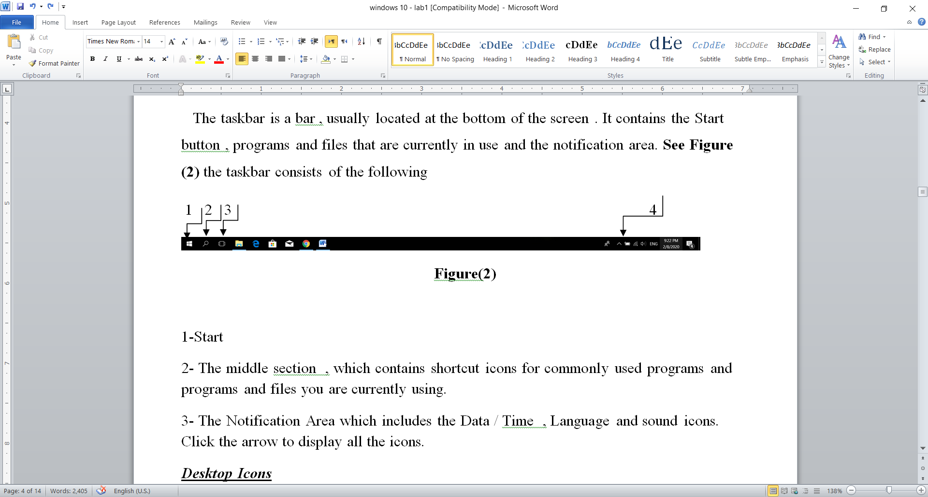

**Figure (3)**

1. **Start**: Click on it you will see a list full of your favorite applications and a complete browsing of all applications installed on the computer. You can also shut down the computer through it or restart it or put it in sleep mode as usual and you can also enter through it to the system settings.Click the start button once with the left mouse button in order to display the start menu as illustrated in as shown in **Figure (4)**.
2. **Search Windows** :To search for any file or folder in the computer
3. **Task View** :Task View is an innovative way to manage active windows. Once you click on it, all open windows turn into thumbnails so they are all visible and then you can move between them and view any of the open applications or close them if you no longer need them. The most exciting feature is the new desktop button located at the bottom The left, which helps you to perform specific tasks on the desktop such as watching movies or editing videos .

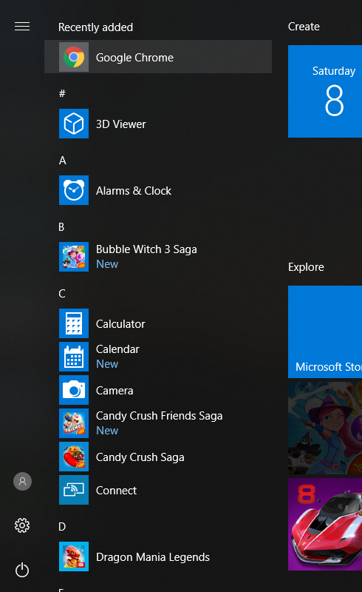

**Figure (4)**

1. **The Middle Section** The file explorer icon is the yellow folder that allows you to browse the contents of your computer and the icons next to it are programs that you install. Some of them come already installed but can be removed. They are shortcuts to programs you can access directly without having to go to the Start menu or the search bar, and you can install any kind of Programs on this tape.

Active programs will appear in the taskbar just like the programs installed in it, but there will be a thin line under it and its background will also be lighter.

1. **The Notification Area** which includes the data/time, language and sound icons. click the arrow to display all the icons.

***Desktop Icons***

Icons are small graphical images that can represent your computer's programs, files and folders. Some common programs icons that are often placed on the desktop are computer , network, control panel and recycle bin .

# *Show desktop icons in Windows 10*

The desktop icons may be hidden. To view them, right-click the desktop, select View, and then select Show desktop icons. To add icons to your desktop such as This PC, Recycle Bin , Control panel andNetwork, as shown in **Figure (5)**

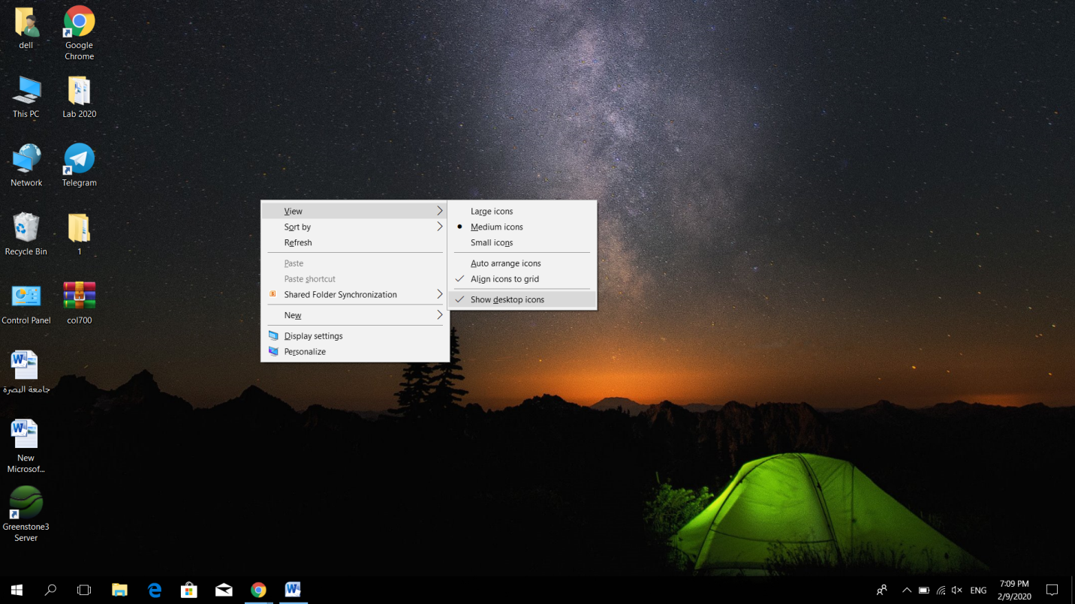

**Figure (5)**

**OR**

1. Select the Start  button, and then select Settings  > Personalization > Themes.
2. Under Themes > Related Settings, select Desktop icon settings.
3. Choose the icons you would like to have on your desktop, then select Apply and OK, as shown in **Figure (6)**

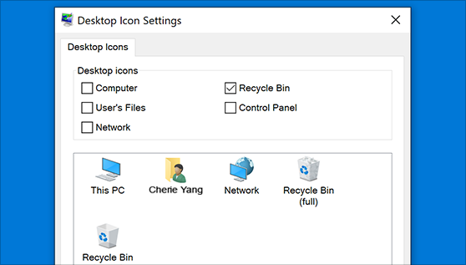

**Figure (6)**

***Start Menu***

Through the Start menu, programs and applications are in our hands directly through :

1. User Account

2. Most Used

3. File Explorer

4. Settings

5. Power

6. All apps

7. Full Screen

***Shut Down Windows***

To shut down your computer, close all applications and then select one of the following options, as shown in **Figure (7)** .

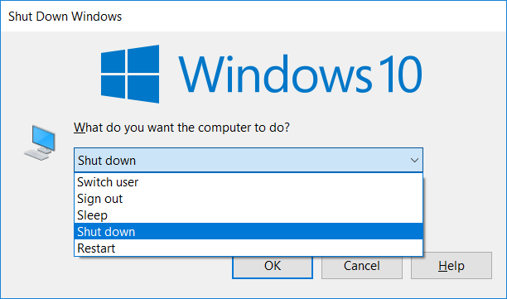

**Figure (7)**

1. **Shut down** : to turn the power off completely . It is recommended to use this option if you want to install a new memory card or other hardware or if you do not plan to use your computer for several days or more, you should also shut it down.
2. **Restart** : to restart the computer if an application has not responded, or if you install a new application.
3. **Sleep** : A state in which your computer consumes less power, but remains available for immediate use.

**Note**

You may set the computer to go into sleep mode by itself after a chosen period of time. Click Control Panel. The Control Panel dialog box will appear, select system and security category , click power options and then change plan settings to specify the period of time on the put the computer to sleep boxas shown in **Figure (8)** .

***start control panel system and security power options change plan***

***settings***

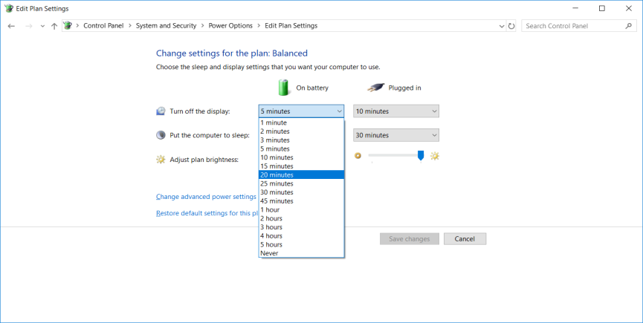

**Figure (8)**

**Note**

For any reason , your computer may stop responding to the keyboard or the mouse clicking. To shut down a non-responding application, press the**(Esc)**button on the keyboard or press**( Alt +Ctrl +Delete)**once. The windows Task Manager dialog box will appear ,as shown in **Figure(9)** .

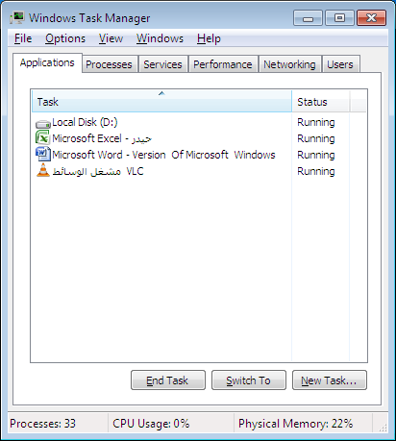

**Figure(9)**

**Note**

* We can use **Lock** from start menu to put the computer on the lock screen. If you want to work on the computer again, click on the lock screen to reopen and run Windows on the last program , we were working on.
* **Sign out** is used to log out of your current account and enter a new account

***Icons management***

**The Folder :**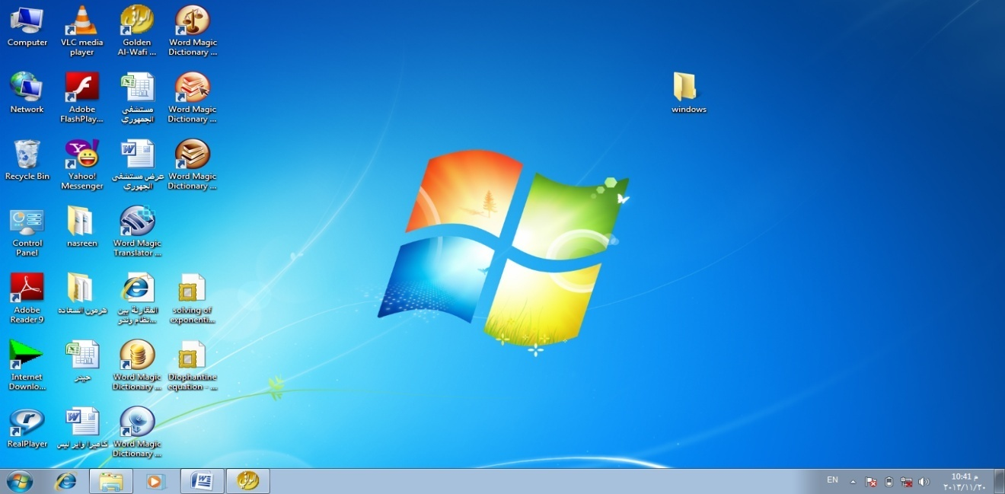

A folder used to store files in an organized way. A folder may contain both files and other folders (subfolder) . It usually appears yellow .

***Parts of Folder Windows***

Any folder window contains many elements , and each element has a specific function.as shown in **Figure(10) .**

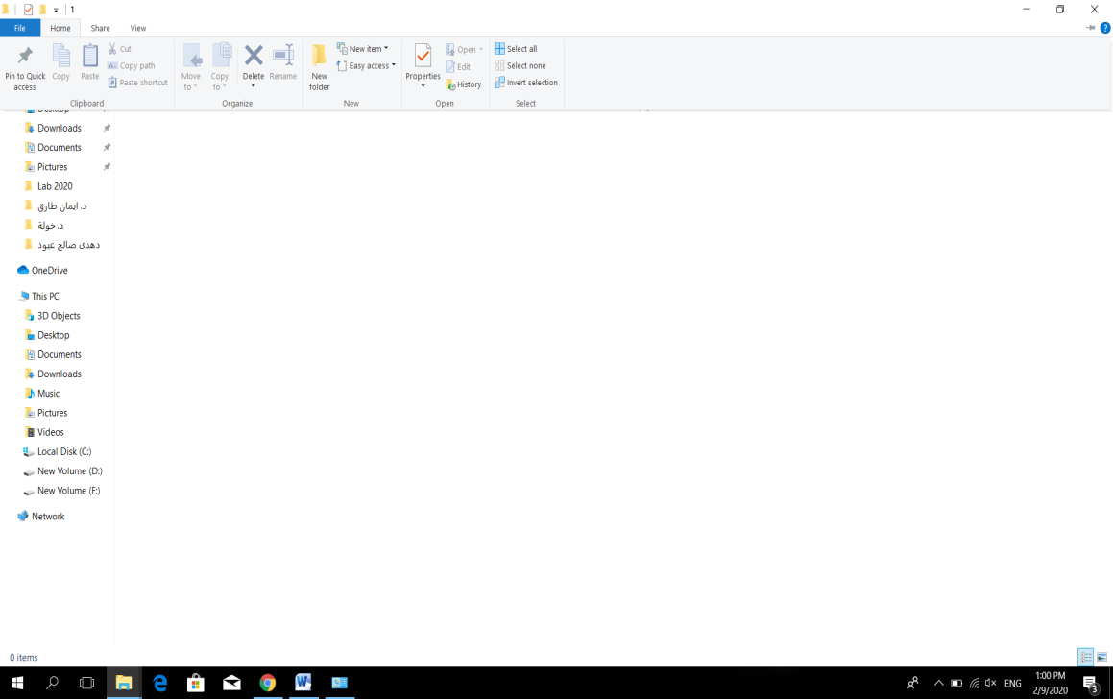

**Figure(10)**

1. **Navigation Pane*:*** Use the navigation pane on the left to access libraries , favorite to open your most commonly used folders and computer to browse folder and drives.
2. **Menu Bar *:***Contains different menus that help you execute many command . Every menu contains shortcut icons that are refer to the commands .
3. **Address Bar *:*** Shows the path for the opened file or folder. You can use the Address bar to move up .
4. **Back & forward buttons *:***Use the back button to return back to the previous window. Use the Forward button to move between open windows .
5. **Search Box *:*** the search box allows a user to search for file or folder on the computer.
6. **Details Pane *:*** The details pane at the bottom shows details about the selected item. The type of information is quite different for different kinds of objects .
7. **Navigation Bar *:***Use the navigation bar to move within the open window .

***Create a Folder***

To create a new folder ,execute one of the following methods after choosing destination folder:

1. Click right button of mouse New Folder Write the name of folder.
2. Press (Ctrl +Shift+N) Write the name of folder.
3. Home New Folder Write the name of folder.

***Files***

The name of a file consists of two parts, ***the file name*** ,is the name you give the file when you save it, and ***the extensions*** which is usually added automatically when you save a file. An extension is asset of three or four letters that tell the computer the kind of the file.

Example:

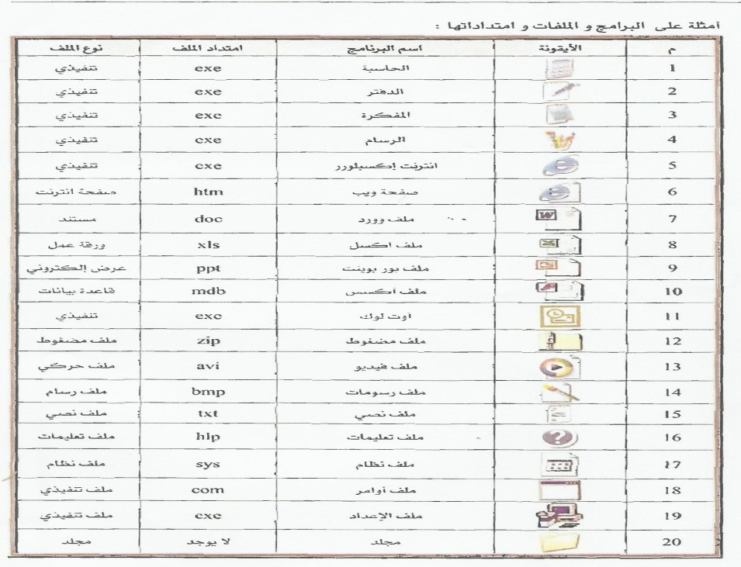

**Figure (11)**

***Selecting Elements***

You must select a file or folder on windows in order to work on it .

1. To select a single object, click on it once .
2. To select all files and folders , in the window ,on the **Hom menu** , click **Select All**, or press **(Ctrl + A**).
3. To select several objects anywhere in a window , hold down the **Ctrl** key while clicking on them in turn .
4. To select consecutive files or folders click the first item ,press and hold down the **Shift** key ,and then click the last item.
5. you can reverse the selection file or folder, **Why?**For example you need to delete /cut/copy… etc.all file of a folder except 2-3 files. So instead of selecting all those files that you want to delete /cut/copy… etc. , you can simply select those 2-3 files and then invert the selection by click **Home** and choose invert selection.

***CopyingIcons***

To copy icons between desktop and folders , execute one of the following methods after selecting Icons that you wish to copy .

1. From Source window Click **Copy** From destination window click **Paste*.***

**Copy**&**Paste** are found in **Home** OR click **right button** on select item.

1. Select the icon that you wish to copy,then press down the mouse button and pressed **Ctrl** and while keeping it pressed drag the icon to the new location .
2. Select the icon that you wish to copy,then press down the mouse button and while keeping it pressed drag the icon to the new location , then select **copy Here *.***
3. Click **Home** and then select **Copy to**, list will appear to select the location .

***Moving Icons***

To move icons between desktop and folders, execute one of the following methods after selecting Icons that you wish to move :

1. From Source window Click **Cut**from destination window click **Paste*.***

**Cut**&**Paste** are found in **Home** OR click **right button** on select item.

1. Select the icon that you wish to move ,then press down the mouse button and while keeping it pressed drag the icon to the new location (destination ) .
2. Select the icon that you wish to move ,then press down the mouse button and while keeping it pressed drag the icon to the new location , then select **Move Here** .
3. Click**Home**and then select**Move to** , list will appear to select the location .

***Deleting Icons***

To delete icons ,execute one of the following methods after selecting icons that you wish to delete :

1. Select delete command from( Keyboard or **Home** or Click Right Button ).
2. Move icons to the Recycle in in one of moving methods (above) .

To delete icons finally press **( Shift + Delete )** .

***Rename***

To rename a folder or file ,execute one of the following methods after selecting icon that you wish to rename

1. Select **Rename** command from( **Home** or **Click Right Button**)
2. Press F2 from keyboard .
3. Click left button of mouse far distant click .

***Rename the contents of folder at once***

To rename the contents of folder at once do the following :

**Open the folder Edit Select All Clickrename command .**

***Sort Files***

To store files by categories (such as date , name , size , and type ), do the following, as shown in**Figure (12)** , Click ***Views***Sort by

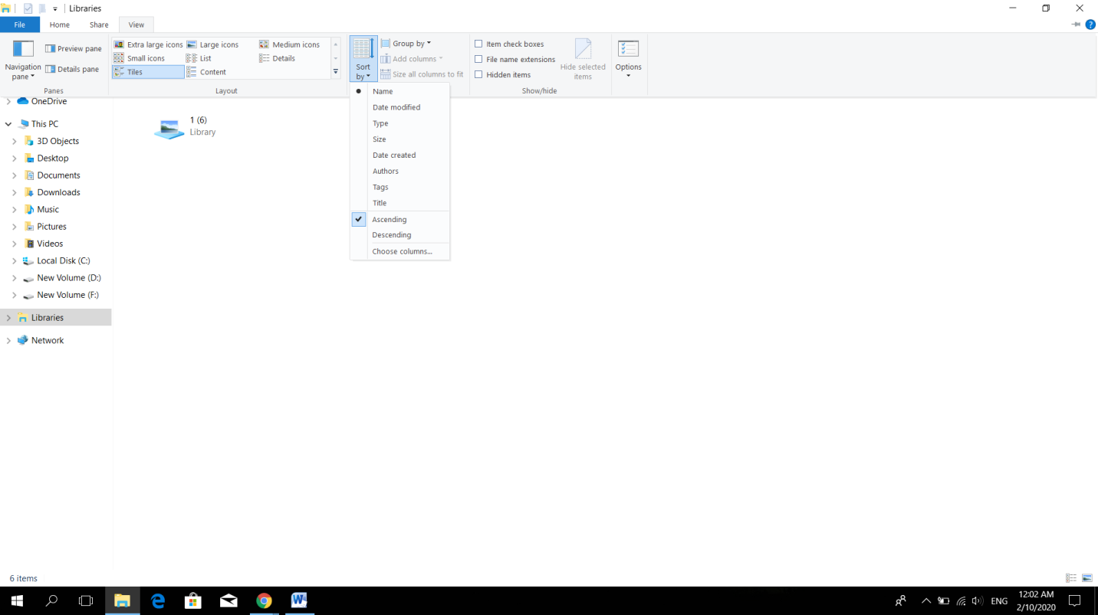

**Figure (12)**

Name : To sort files by name .

1. Date Modified : To sort files by last edited.
2. Type : To sort files by type .
3. Size : To sort files by size .
4. Date Created : To sort files by created files.
5. Ascending : To sort files ascending .
6. Descending : To sort files descending .

***View Files***

You can view files and folders in many ways and change the size and presentation of items.There are more than one method to organize the way files are displayed in windows explore by click the **view menu** then choose one of the following from layout group ,as shown in**Figure (13)**.



**Figure (13)**

1. Extra-large icons
2. Small icons
3. Large icons
4. Tiles
5. List
6. Content
7. Medium icons
8. Details

***Recycle Bin***

You can save the files that were deleted in the recycle bin , and restore the deleted files as long as they are in the recycle bin.

To restore the deleted file to the location from which it was deleted ,do the following :-

Open the Recycle Bin :-

1. Select item→ restore this item from toolbars.
2. Select item → right click → Restore.
3. Select item→file→Restore.

To delete all items from Recycle bin ,do the following :-

1. Right click on the Recycle bin → Empty the Recycle Bin.
2. From toolbars→ Empty the Recycle Bin.
3. file→ Empty the Recycle Bin.

You can empty the Recycle Bin without opening it by right-clicking and selectingEmpty Recycle Bin .

***Notepad and Wordpad***

start Windows Accessories Word pad

start WindowsAccessories Notepad

***Searching for Files or Folders***

It is searching for files or folders you want to work on, or the ones you forgot where they were saved.

To search files and folders, do the following:

1. Open ‘my computer’, you will see the Search box at the top of the window.
2. Enter the file name or subname. A set of files will show that match the search.

**For example**

a*.xlsx , (*)expresses a set of characters

R?.docx , (?) expresses one character

***Print Screen***

Press **(PrtSc)** on the keyboard to take a screenshot of the whole screen.

Press **(Alt)** and **(PrtSc)** at once to take a screenshot of the activated window only.